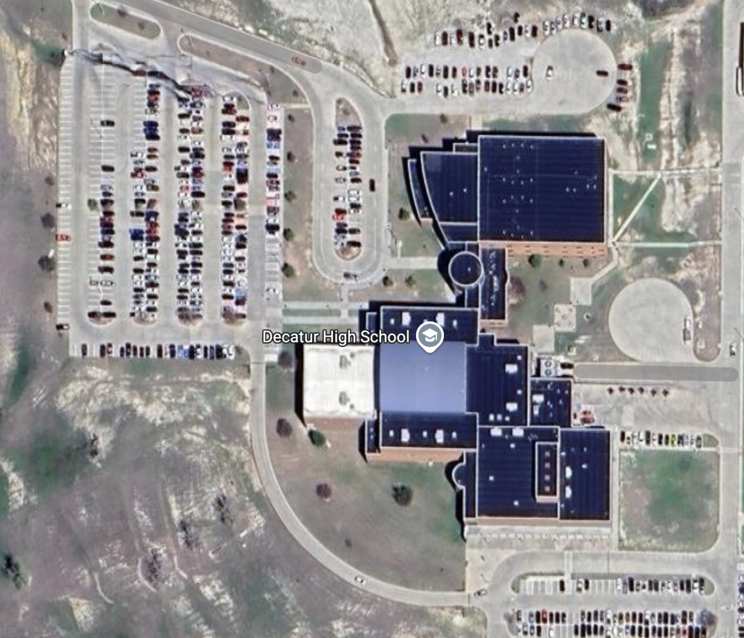
B
U
S

PARKING
USE ENTRANCE OFF FM 730

PARKING LOT FOR FANS
USE ENTRANCE OFF OF FM 730
PARK IN DESIGNATED AREAS.
ENTER BUILDING IN THE GYM ENTRANCE
PLEASE DON’T ENTER BUILDING UNTIL THE APPROPRIATE TIME
BAND HALL
AUDITORIUM
ENTRANCE
GYM
NO PARKING/ NO ENTRANCE

